Nome: __________________________________________ Data: ___/___/___

Ficha de trabalho de Língua Portuguesa

Pinta o i e I e completa o exercício.

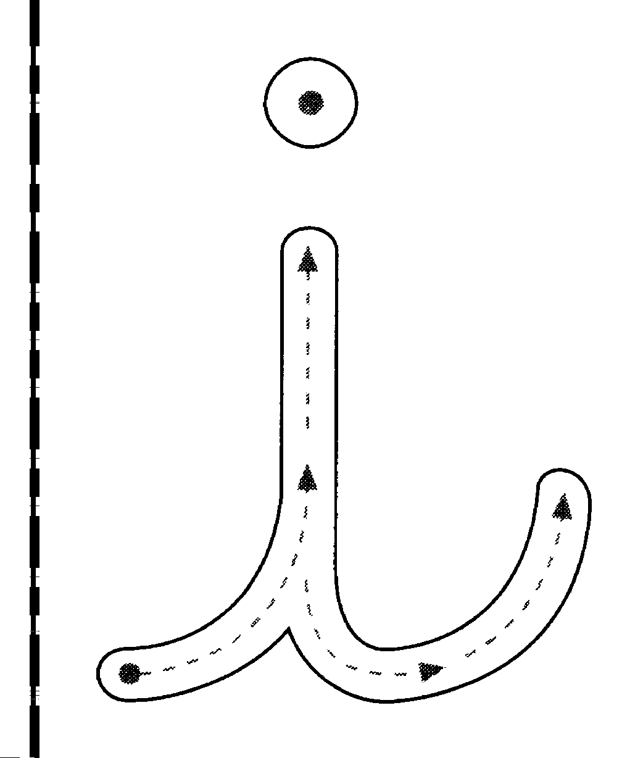
________________________________________________________
___________________________________________________________________

________________________________________________________
___________________________________________________________________

________________________________________________________
___________________________________________________________________
i

________________________________________________________
___________________________________________________________________

________________________________________________________
___________________________________________________________________

________________________________________________________
___________________________________________________________________


________________________________________________________
___________________________________________________________________

I
___________________________________________________________________

________________________________________________________

___________________________________________________________________

________________________________________________________

___________________________________________________________________

________________________________________________________

___________________________________________________________________

________________________________________________________

___________________________________________________________________

________________________________________________________

___________________________________________________________________

________________________________________________________

___________________________________________________________________

________________________________________________________

