Nome: __________________________________________ Data: ___/___/___

Ficha de trabalho de Língua Portuguesa

Pinta o u e U e completa o exercício.

________________________________________________________
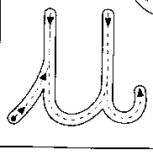
___________________________________________________________________

________________________________________________________
___________________________________________________________________

________________________________________________________
___________________________________________________________________

________________________________________________________
u
___________________________________________________________________

________________________________________________________
___________________________________________________________________

________________________________________________________
___________________________________________________________________

________________________________________________________
___________________________________________________________________



___________________________________________________________________

________________________________________________________

___________________________________________________________________

________________________________________________________
UI

___________________________________________________________________

________________________________________________________

___________________________________________________________________

________________________________________________________

___________________________________________________________________

________________________________________________________

___________________________________________________________________

________________________________________________________

___________________________________________________________________

________________________________________________________

