Nome: __________________________________________ Data: ___/___/___

Ficha de trabalho de Língua Portuguesa

Pinta o o e O e completa o exercício.

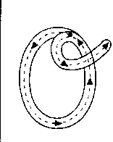
________________________________________________________
___________________________________________________________________

________________________________________________________
___________________________________________________________________

________________________________________________________
___________________________________________________________________
o

________________________________________________________
___________________________________________________________________

________________________________________________________
___________________________________________________________________

________________________________________________________
___________________________________________________________________


________________________________________________________
___________________________________________________________________

___________________________________________________________________

________________________________________________________

___________________________________________________________________

________________________________________________________
OI

___________________________________________________________________

________________________________________________________

___________________________________________________________________


________________________________________________________

___________________________________________________________________

________________________________________________________

___________________________________________________________________

________________________________________________________

___________________________________________________________________

________________________________________________________

