Nome: __________________________________________ Data: ___/___/___

Ficha de trabalho de Língua Portuguesa

Pinta o a e A e completa o exercício.


________________________________________________________
___________________________________________________________________

________________________________________________________
___________________________________________________________________

________________________________________________________
___________________________________________________________________
a

________________________________________________________
___________________________________________________________________

________________________________________________________
___________________________________________________________________

________________________________________________________
___________________________________________________________________

________________________________________________________
___________________________________________________________________

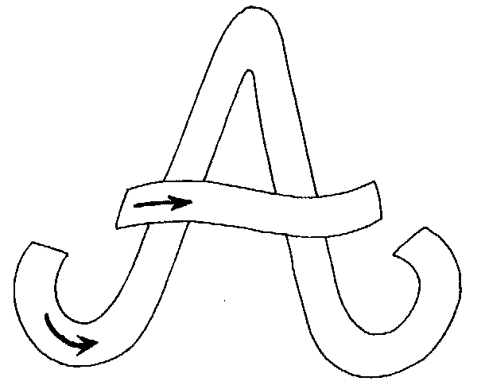

___________________________________________________________________

________________________________________________________

___________________________________________________________________

________________________________________________________
AI

___________________________________________________________________

________________________________________________________

___________________________________________________________________















