Nome: ___________________________________________________ Data: ___/___/___

Ficha de trabalho de Língua Portuguesa

Pinta o e e E e completa o exercício.


________________________________________________________
_________________________________________________________

________________________________________________________
________________________________________________________

________________________________________________________
________________________________________________________

________________________________________________________
________________________________________________________

________________________________________________________
e
________________________________________________________

________________________________________________________
________________________________________________________

________________________________________________________
________________________________________________________

________________________________________________________
________________________________________________________
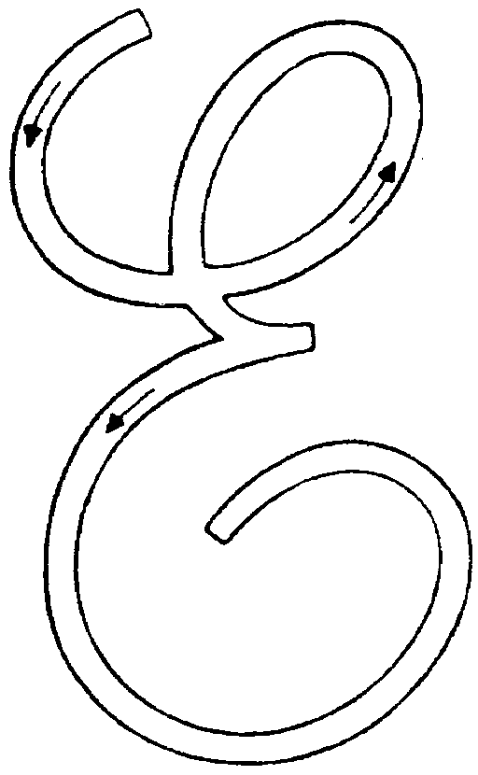

___________________________________________________________________

________________________________________________________

___________________________________________________________________

________________________________________________________

___________________________________________________________________
E

________________________________________________________

___________________________________________________________________

________________________________________________________


















