1. Lê e copia:

____________ ____________ ____________ _____________

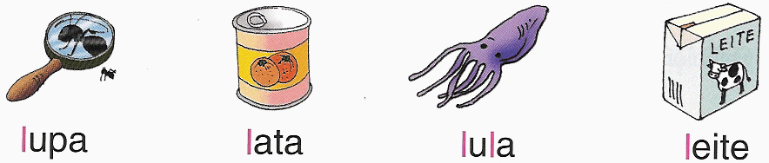

_____________ ____________ ______________ ______________

2. Lê e escreve as frases:

____________________________________
