Nome _______________________________________________________

Data ________________________________________________________

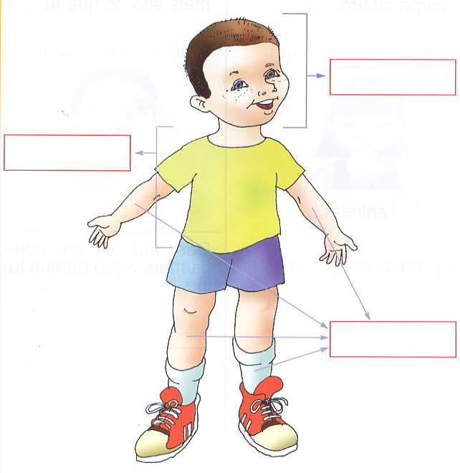

……………………………………………………………………………...................................

cabeça tronco membros

